

Name : ZHANG ZITENG

Student ID : TP052096

Intake : UC2F1908IS

Lab Group : Group 1



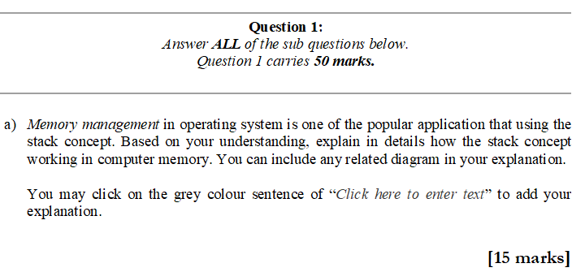

**Answer:**

In general, the stack automatically allocates variables, stores function parameter values, and local variable values. It is some space used when the function is called. Its address decreases from high to low.

The working principle is that the variable is automatically assigned first, it is fast but the programmer cannot control it. For example, declare a local variable int b in the function; the system automatically creates space for b on the stack.

Secondly, if there is enough remaining space of the stack, memory will be provided to the system, or there will be an exception and the stack will overflow.

At last, stack is a data structure of a continues area of memory that extends to a lower address. The top address and the maximum capacity of the stack are predetermined by the system. For example, suppose the capacity of the stack is set to 2M at beginning. Overflow will happen if the requested space is bigger than the remaining space on the stack.

(GeeksforGeeks,2014)

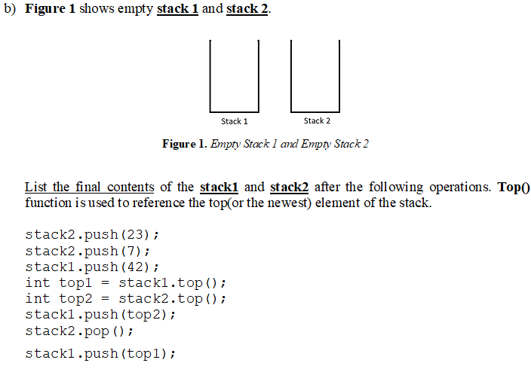

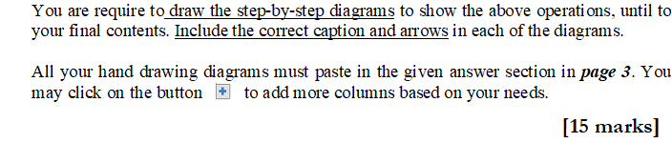

**Answer:**

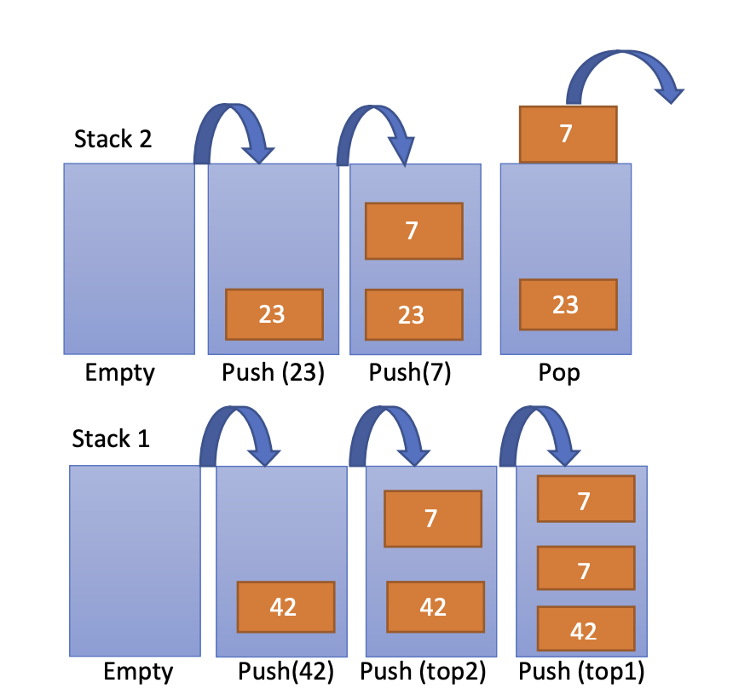

The final content:

Stack 1: {7,7,42}

Stack 2: {23}.

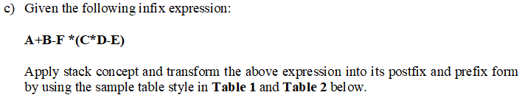









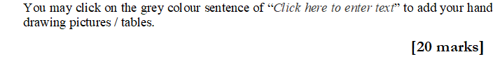

**Your answer:**

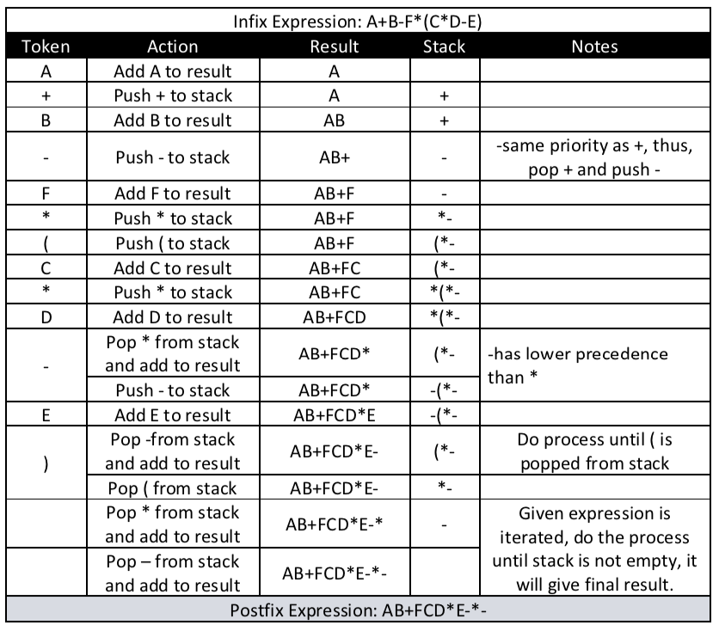

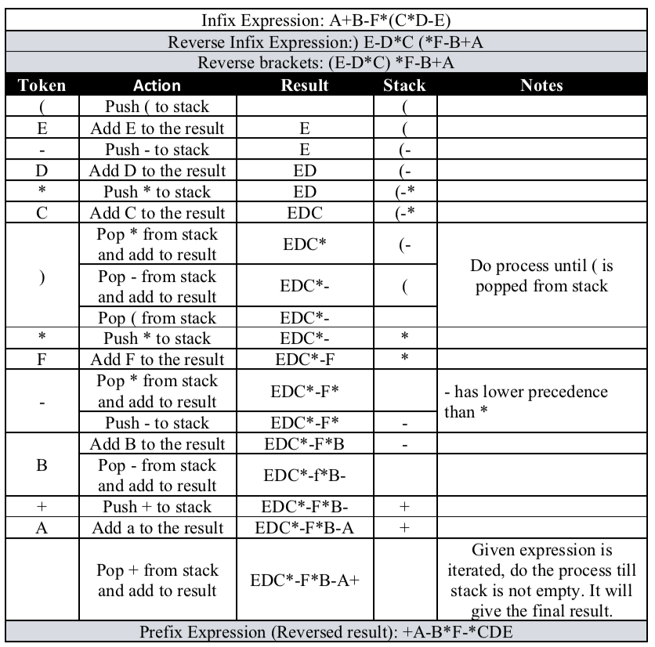

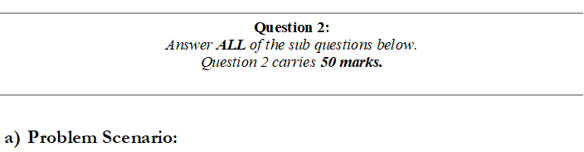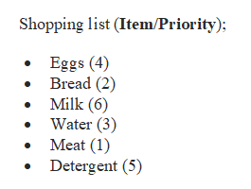

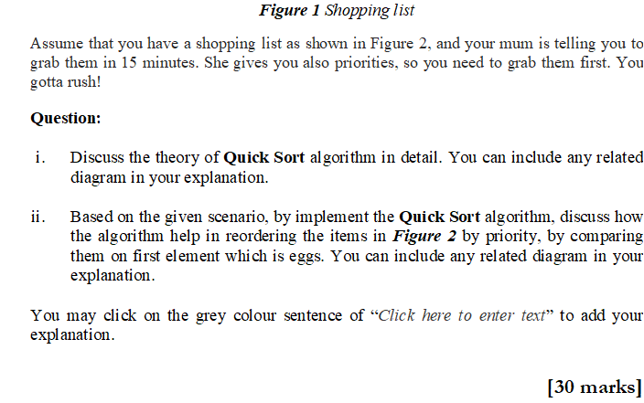

**Answer:**

i.

The basic logic of quick sorting is to first take an element from the sequence as a pivot. There are many types of selection methods for this element, you can choose the first, last, random or median. The logic of different methods is similar, the difference lies in the different algorithms. Partition this element to the left and right. During the partitioning process, place all the elements that are larger than this element on the right, and those that are less than or equal to it on the left. Then repeat the partitions for the left and right sections until each section has only one number.

ii.

|  |  |  |  |  |  |
| --- | --- | --- | --- | --- | --- |
| Assume the shopping list is a group of element as follow: | | | | | |
| Egg | Bread | Milk | Water | Meat | Detergent |
| 4 | 2 | 6 | 3 | 1 | 5 |
| First Element is Egg (4). | | | | | |
| First sort: | | | | | |
| Bread (2) | Water (3) | Meat (1) | Egg (4) | Milk (6) | Detergent(5) |
| <= egg (4) | | |  | > egg (4) | |
| Group 1 | | |  | Group 2 | |
| Assume the first element for group 1 is bread (2).  First sort for group 1: | | |  | Assume the first element for group 2 is Milk (6).  First sort for group 2: | |
| Meat (1) | Bread (2) | Water (3) |  | Detergent(5) | Milk (6) |
| <= Bread (2) |  | > Bread (2) |  | < Milk (6) |  |
| So the final result by using quick sort is: | | | | | |
| Meat (1) | Bread (2) | Water(3) | Egg(4) | Detergent(5) | Milk(6) |

The first element is Egg(4). So set Egg(4) as pivot. All the element smaller or equal 4 go to left, all the element bigger than 4 go to right. Then we divide the elements into 2 groups. Which is group 1(smaller or equal to 4) and group 2(bigger than 4). Then repeat the last step which is to set an elemnt for each group as their pivot. And sort again. Finally, we can got the result:

Meat(1) -> bread(2) -> water(3) -> egg(4) -> detergent(5) -> milk(6)

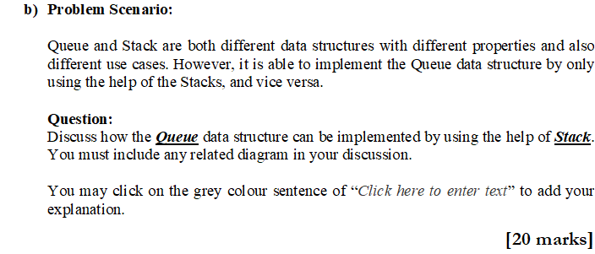

**Answer:**

The main feature of the stack is first in / last out. The main feature of the queue is first in / first out. So using the stack to realize the queue can also be understood as the process of converting first in last out into first in first out.

For example, a group of numbers from low to high are 1 2 3. If the stack is used, the data extraction order is 3 2 1, and the queue extraction order is 1 2 3. However, if you add another stack. Put the array of stack 1 into stack 2 in turn, then the order of stack 2 from low to high will become 3 2 1 as you see in the following stack 2 image. The data extraction order of stack 2 becomes 1 2 3. This indirectly realizes the first in first out which is queue data structure.

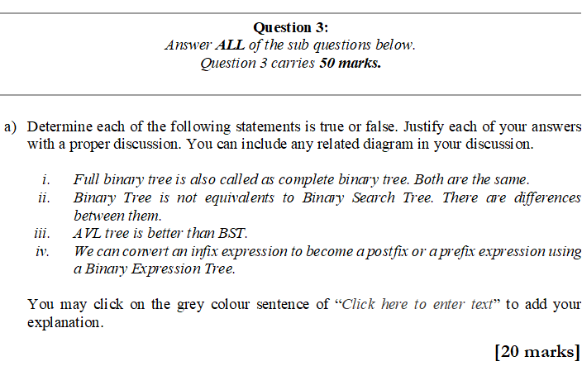

**Answer:**

i. False

Every node except leaves must have two children for the full binary tree.

Differently, each level other than the last should be completely filled and all of its nodes must be as far left as possible for the complete binary tree.

ii. True

Binary tree is a non linear data structure. Every node except leaves must have two children.

Binary seach tree, all values in its left subtree must be smaller than the node, and all the values in its right subtree must be bigger than the node.

iii. True

AVL tree can access data more efficiently than BST. AVL is a balanced BST, the node is 1 bigger than its Left Sub Tree and 1 smaller than the Right Sub Tree. Thus, the height of AVL tree when rotation is always 0(log n).

iv. True

They are all kind of data structure. However, expression tree is a binary tree, its internal node corresponds to operator and each leaf node corresponds to operand which makes it convertible.

(GeeksforGeeks,2015)

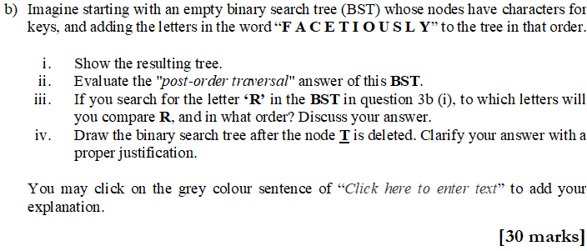

**Answer:**

i. adding the letter in the word FACETIOUSLY

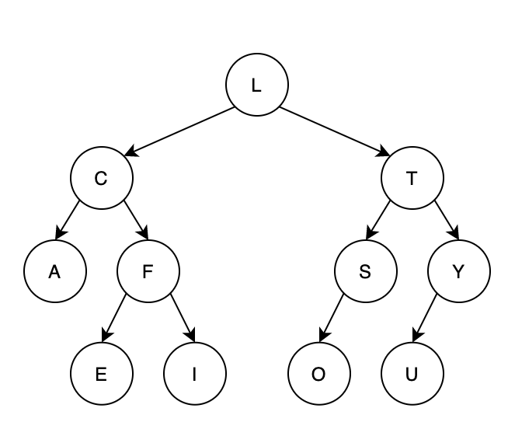

ii.

Post order traversal: A E I F C L O S U Y T L

iii.

To search letter R, firstly it will go right of the node L, because R is greater than L. Then because R smaller than T, so go to the left of subnode T. Next, becase R is smaller than S, it will go to the left of S. Lastly, becase O is the leaf of S, so compare R with O.

iv.

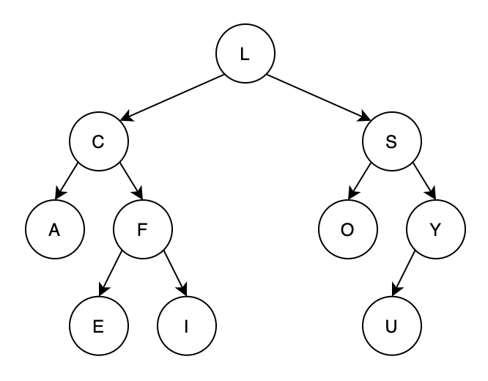

The node T to be delete has nonempty left and right subtrees. Then delete node T, change to S, S change to O. Now S is the node instead of T.

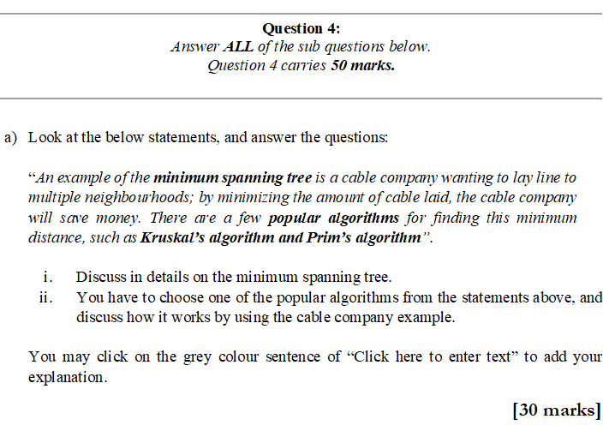

**Answer:**

i.

Spanning tree is a acyclic graph that include connected edges and vertex as a collection. A graph may include more than one such spanning trees. The value of cumulative edge weights is the smallest, it it a minimum spanning tree. which means a acyclic graph that touches every vertex by using the least path.

ii.

I want to choose Kruskal's algorithm to discuss how it works in this case.

First step is to sort all the lines among multiple nerighbourhoods in non-decreasing order of their weight.

Second step is to pick the smallest cable laid. Check if it forms a cycle with the spanning tree formed so far. If the cycle is not formed, this line will be included. Otherwise discard it.

Repeat step 2 until the number of lines among each nerghbourhoods equals to the number of all the nerighbourhoods minuse one (V-1). That is the final Minimum Spanning Tree(MST).



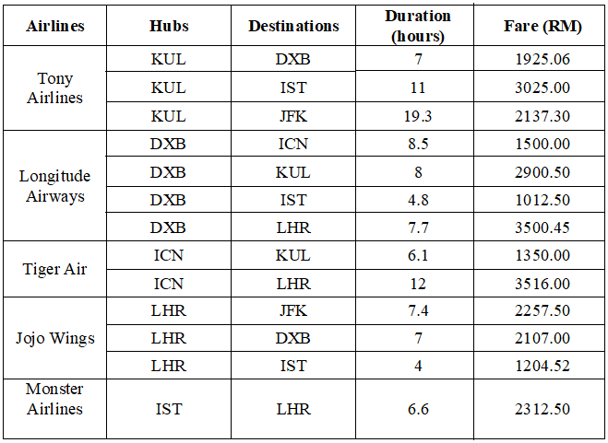

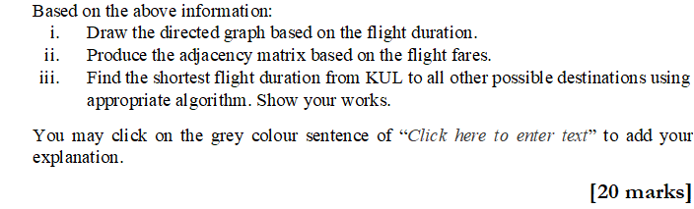

**Answer:**

i.

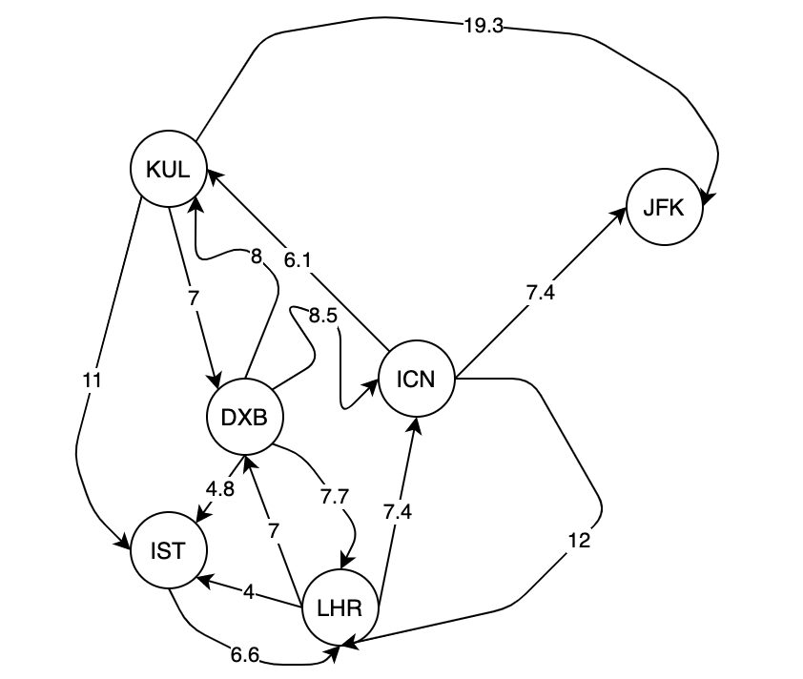

ii.

Base on binary

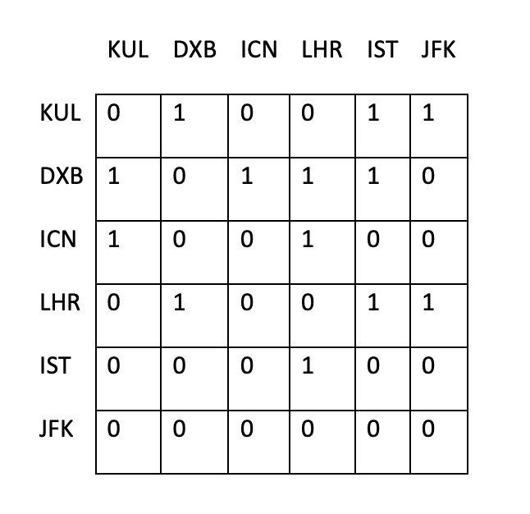

Base on flight fares:

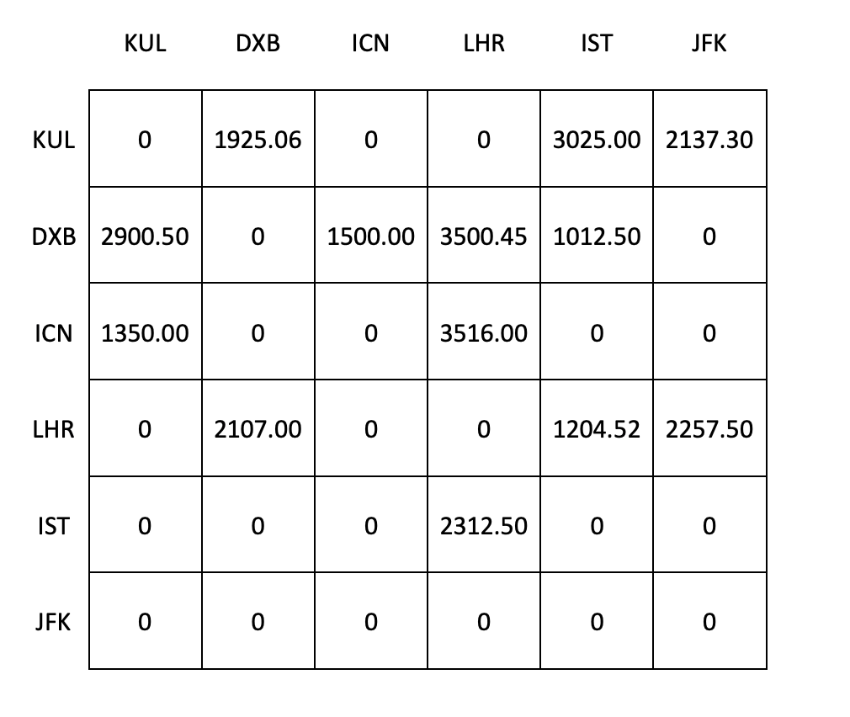

iii.

The best algorithm to find the shortest distance is Dijkstra's Algorithm.

Firstly, find all the distance as sets from KUL to each one.

KUL->DXB {7,24.6}

KUL->IST {11,11.8,18.7}

KUL->LHR{14.7,17.6,27.5}

KUL->ICN{15.5,21.4,25}

KUL->JFK{19.3,22.9,29.5,32.4}

The set from shortest to longest is

{KUL,DXB,IST,LHR,ICN,JFK}

The shortest path tree is as follow:

